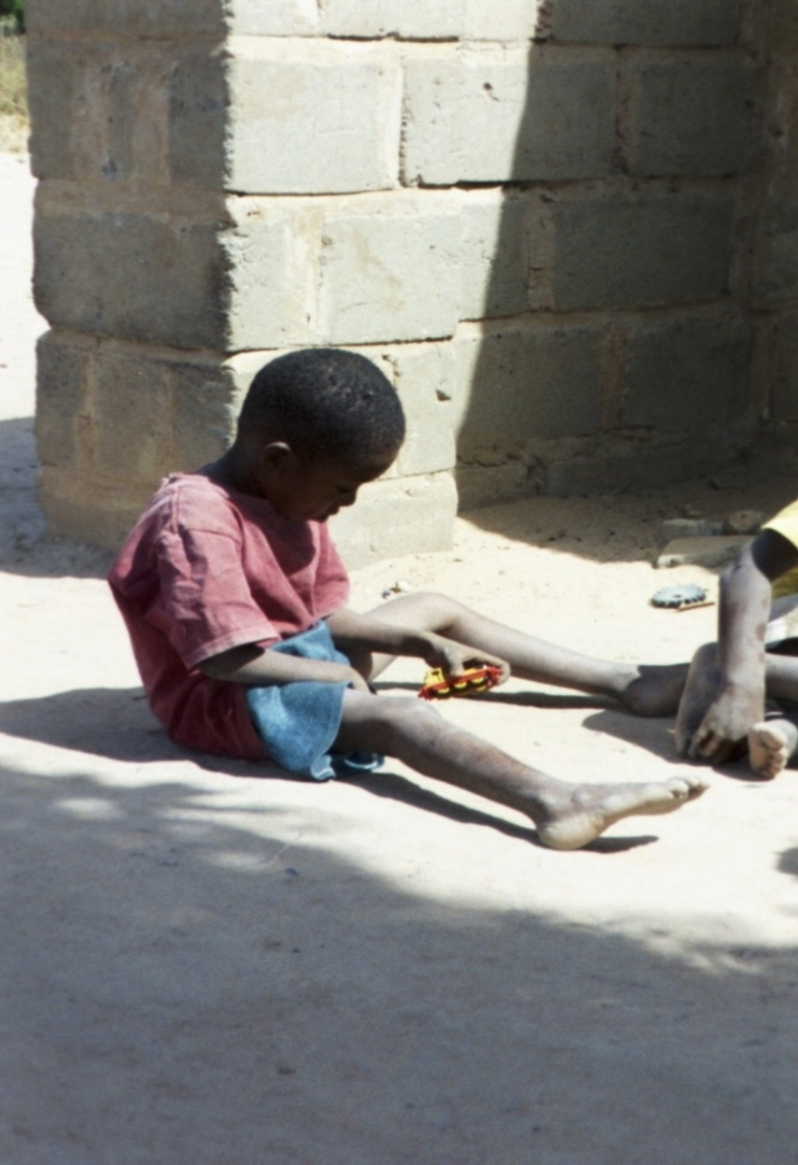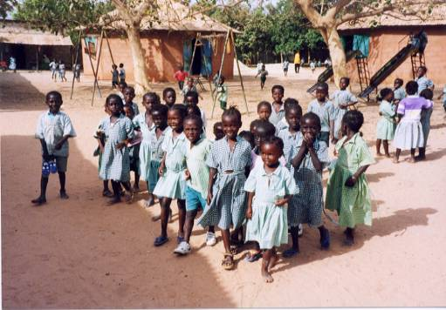

**Friends of The Gambia**

**Association CIO**

FoTGA SAFEGUARDING POLICY

Including our statement about

Female Genital Mutilation

FGM

Updated July 2019

**FoTGA wishes to encourage the sponsoring of the education of less advantaged children and young people in The Gambia.**

**If the guidelines in this leaflet are followed then it should provide protection, not only for children and young people, but also against false allegations against FoTGA members.**

**FoTGA’s**

**Good Practice and Advice**

**Do** treat all children, young people and vulnerable adults equally with respect and dignity.

FoTGA encourages open communications, but there should be **no secrets** between young people and any member.

As far as possible a member should **never be alone** with a child or a young person where activity cannot be seen by others.

**Do not** invite a child or young person to your hotel or lodgings alone.

**Do not** respond to invitations by children or young person to visit their compound **unless** the child is accompanied by an adult.

**Do not** have any contact with a child or young person that could be construed as inappropriate.

**Do** listen carefully to children and young people. **Do not** assume you know what they are thinking and feeling.

**Do not** invade a child’s or young person’s privacy by inappropriate contact or language.

**Do not** respond to excessive attention seeking from a child or young person that is overtly sexual or physical in nature.

**Do not** belittle, ridicule or reject a child or young person.

**Do use common sense - ALWAYS put the welfare of each child, young person and vulnerable adult first.**

**Friends of The Gambia Association CIO**

**FoTGA**

**Safeguarding Policy Statement (To include FGM)**

As Members, Officers, Sponsors and paid staff of The Friends of The Gambia Association CIO (FoTGA) we are committed to the nurturing, protection and safekeeping of all those with whom we come into contact in The Gambia, particularly children, young people and vulnerable adults.

FoTGA recognises it is everyone’s right, including a child’s, to be safe and happy in the activities they undertake.

It is the responsibility of each one of us to prevent the physical, sexual and emotional abuse of children, young people and vulnerable adults.

FoTGA believes all girls and young women should be able to live their life free from torture and degrading treatment. FGM is recognised internationally as a devastating form of violence against women and girls and a violation of their human rights. The Banjul Declaration of July 22, 1998 condemned its continued practice.

It is the responsibility of each one of us to report any abuse discovered or suspected to the Police.

Each member of FoTGA will be given and asked to read a copy of its Safeguarding Policy, and to affirm that they will abide by it.

Any member of FoTGA who has been convicted of child abuse will have his or her membership revoked with immediate effect.

**Child Right Tourism**

In The Gambia prostitution is illegal and paying anyone under 18 in cash or kind (meals, clothing and accommodation etc.) for sexual contact is punishable by both Gambian (updated February 2011) and UK law. Conviction will result in a lengthy prison sentence, a hefty fine and the individual being placed on the “Sexual Offenders Register” in the UK.